

**PROJECT DELIVERABLE 4**

**GROUP MEMBERS:**

|  |  |
| --- | --- |
| **NAME** | **ROLL NUMBER** |
| HAIDER ARSHAD | 20I-2379 |
| SHERAZ TARIQ | 21I-1188 |

**TITLE:**

*“TRIP BRIGHT”*

**Introduction to Project:**

Most of the applications don’t provide the features and interface, reliable with age, secure the user privacies, easy advance bookings, and place suggestions. So, this application would provide a fully functional feature.

**Personas and Scenarios:**

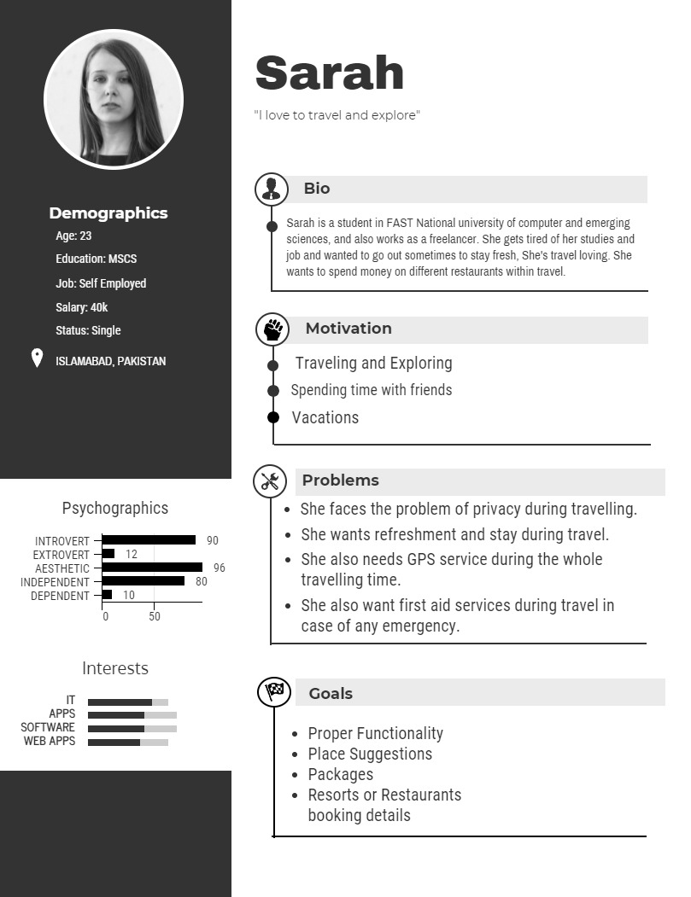

**Problems:**

* She faces the problem of privacy during travelling.
* She wants refreshment and stay during travel.
* She also needs GPS service during the whole
* travelling time.
* She also wants first aid services during travel in
* case of any emergency.

**Wants:**

* She wants an app which is easy to use and have proper functionality in it.
* She wants to make quick selection without asking anyone, through app.
* She also wants a place suggestion feature in the app so that she can choose the place easily.
* She also wants to book resorts or restaurants from app.
* She also wants to know booking details of restaurants and hotels.

**Wishes:**

* She wants an AI-Based app which learns her personality and show results accordingly.
* She wants interface which is easy to use and user-friendly.

**User Story:**

Sarah wants to travel. She loves travelling and she wanted to book seats, hotels, resorts, and other services before she starts travelling. She decided all the services and want to book all the services from home by using an application.

**User Scenario:**

Sarah loves travelling and she is given a responsibility to book the tour services for their office colleagues. She was looking for tourism application which helps her to book all the services for her and their colleagues too. She started to research on the internet for the booking of tourism, she got a lot of stuffs and she also need a quick response by which she can easily decided and get to know about the places they wanted to visit.

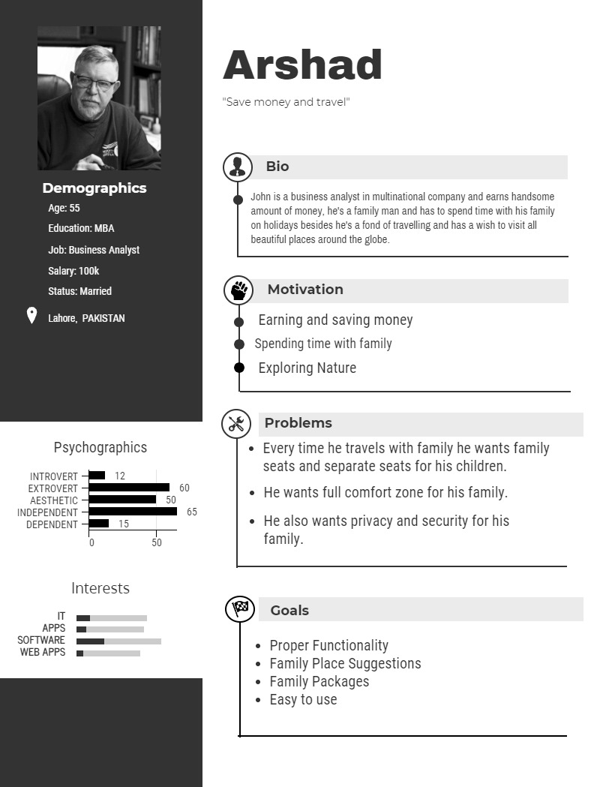

**Problems:**

* Every time he travels with family
* He wants family seats and separate seats for his children.
* He wants full comfort zone for his family.
* He also wants privacy and security for his
* family.

**Wants**:

* He wants proper functionality in the app with an easy interface.
* He wants the app to give suggestions of Family Places so that he can take his family for the vacations with him.
* He wants the system to give family packages which are suitable and affordable for his family.

**Wishes:**

* He wishes to perform any task in minimum and easy steps so that he can easily confirm his tours without any difficulty.
* He wishes to have special discounts for his family.

**User Story:**

Arshad wanted to take his family tour. He decided to book all the traveling services from internet. He needs to book all the services from his home.

**User Scenario:**

Arshad loves travelling and he is responsible father too. He was looking for tourism application which helps his to book all the services for his and their children too. He started to research on the internet for the booking of tourism, he got a lot of stuffs and he also need a quick response by which he can easily decide and get to know about the places they wanted to visit.

**User Scenario:**

The user wants a tour guide with them. A team is going for the outside of the country and the team doesn’t know about any guide who help them. They were searching on the internet and found our mobile application through which they get help to book all the travelling services. As well as the travelling packages which saves their money and the total cost comes very low as they think earlier.

**Structured Specifications:**

1. **Login:**

|  |  |
| --- | --- |
| **SECTION** | **CONTENT** |
| **Designation** | UC-12-38 |
| **Name** | Login |
| **Author** | Masood |
| **Priority** | Importance for system success: **high**  Technological risk: **high** |
| **Critically** | high |
| **Source** | Sheraz (Admin Expert) |
| **Responsible** | Arshad |
| **Description** | The user wants to login to a trip bright account by which the user can perform their tasks according to their role. |
| **Trigger Event** | The user wants to login to their created account. |
| **Actors** | User, admin, and Trip Bright verification server. |
| **Pre-Condition** | User must provide a login email and password. |
| **Post-Condition** | User has successfully logged in. |
| **Result** | Chill study gets open and the user carries out his tasks. |
| **Main Scenario** | 1. The trip bright server asks for the loading of the login portal. 2. The user gets the login page after requesting a login page. 3. The system should give alternate options for the login. 4. The user had **forgotten the password** option in case of a forgotten password. 5. After clicking on the forgotten password, the system asks for several verifications. 6. The entered email and password is correct. |
| **Alternative Scenarios** | 1. User can directly login through his google account. 2. Users can use phone number instead of email for log in. |
| **Exception Scenario** | The user is unable to login to his/her account in case of not registered yet. |
| **Qualities** | Reaction time upon user input  Operating comfort |

1. **Payment Method**

|  |  |
| --- | --- |
| **SECTION** | **CONTENT** |
| **Designation** | UC-12-39 |
| **Name** | Login |
| **Author** | Masood |
| **Priority** | Importance for system success: **high**  Technological risk: **high** |
| **Critically** | high |
| **Source** | Sheraz (Admin Expert) |
| **Responsible** | Arshad |
| **Description** | The mode of payments for the user. User of type tourist have to pay, and the application receive payment through different modes. |
| **Trigger Event** | Payment options were provided to deposit and withdraw the payments. |
| **Actors** | User, admin and trip bright verification server. |
| **Pre-Condition** | User has to provide credit/debit or jazz cash details for payments. |
| **Post-Condition** | Payments provided accounts are verified according to the details provided. |
| **Result** | Payments can be done through bank accounts. |
| **Main Scenario** | 1. The trip bright asks for setting the payment options. 2. The user selects his/her payment method. 3. The system should suggest the bank names according to their provided locations. 4. The user accounts are verified from the banking server. 5. The user can cancel his/her travelling any time. 6. The user can activate the special offers of discounts for long live using. |
| **Alternative Scenarios** | 1. Payments through google play can be done through service networks. 2. Users can withdraw/deposit a specific maximum amount. |
| **Exception Scenario** | Payments options cannot be displayed for the user if they cannot provide the correct details. |
| **Qualities** | Reaction time upon user input  Operating comfort |

1. **Packages**

|  |  |
| --- | --- |
| **SECTION** | **CONTENT** |
| **Designation** | UC-12-40 |
| **Name** | Packages |
| **Author** | Masood |
| **Priority** | Importance for system success: **high**  Technological risk: **high** |
| **Critically** | high |
| **Source** | Sheraz (Admin Expert) |
| **Responsible** | Arshad |
| **Description** | The user can click on the packages offer by the mobile application. |
| **Trigger Event** | The user should be new. |
| **Actors** | User, admin and trip bright verification server. |
| **Pre-Condition** | Users can login into the application to avail packages option. |
| **Post-Condition** | User details were checked. |
| **Result** | User visit packages and avail successfully. |
| **Main Scenario** | 1. The user has to login into application. 2. The user can avail the packages if he/she is eligible. 3. The packages for families and the couples to attract more users. 4. Details were provided to avail the packages. 5. For a regular customer the offers are more, and data is stored in the database. |
| **Alternative Scenarios** | 1. The user would only view the packages if he/she doesn’t want to. |
| **Exception Scenario** | The user cannot avail the regular offers if he/she is not a regular customer. |
| **Qualities** | Reaction time upon user input.  Operating comfort. |

**All Prototypes:**

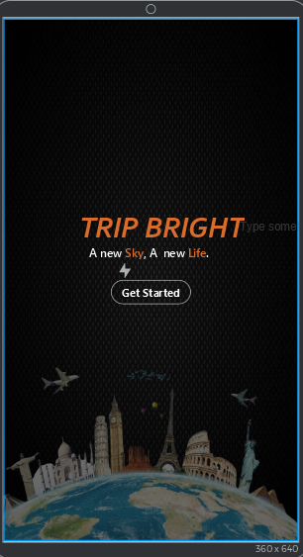

**

**

**Evaluation**

* **Experiment**

**Independent and Dependent Variables**

|  |  |
| --- | --- |
| **Question** | **Rating** |
| How satisfied are you with process of login/registration? | 3 |
| How satisfied are you with the process of booking a vehicle for the trip? | 4 |
| How satisfied are you with the process of booking a resort for your trip? | 4 |
| How satisfied are you with the packages tab? | 3 |
| How satisfied are you with the process of payment? | 3 |
| How satisfied are you with the understanding of basic functionalities of an application? | 3 |
| How easy was it for you to remember the basic functionalities of an application? | 3 |
| How do you find the icons on the application useful? | 3 |
| Do you think you had to click too much to get what you were looking for? | 3 |
| Was the contrast satisfying enough to let you read the website/page content clearly? | 3 |
| Were you able to navigate to other pages easily? | 4 |
| Did the links take you to the relevant pages? | 4 |
| Did it take too long to load the app/app's page? | 3 |
| On a scale of 1-5, how would you rate the performance of the application? | 4 |

**LIST OF TASKS TO BE PERFORMED**

The following list of tasks will be performed by the students over the website:

**For Trip Bright** ([https://www.tripbright.com/#hp-just-for-you](https://www.daraz.pk/#hp-just-for-you))

1. Open the web browser and go to the website (tripbright.com).
2. Click on the **Get Started** button to proceed for the login or signup.
3. Enter your credentials to create a Trip bright account or you can register through google or Facebook account.
4. After creating an account, go to the **LOGIN** tab on the upper side of the navigation bar.
5. Login using either of the following options:

* Email/Password
* Facebook
* Google

1. After login you reached the home*.*
2. In the upper side there is a navigation bar from which you can proceed to the*:*

* Bookings
* Packages
* Resorts
* Login Signup
* Payments

1. In the Packages there are a lot of packages and offers at a great discount.
2. You can click on the Avail Offer button to get a discount of your choice.
3. In the Bookings navigation bar, you can book a journey you wanted to.
4. Click on the Book Now button to book your journey.
5. In the Resorts Navigation bar, you can book your resort for food and rest.
6. Click on the Book Resort button to book a Resort of your choice.
7. When you click on the Book Resort button a payment form appears on the screen which will ask the details about the payment.
8. In the payment navigation bar, a form of payment is appeared on the screen and ask for the details like:

* Name
* Email
* Location Name
* Address
* Payment type

1. Click on the pay now button to pay.

**RESULTS**

|  |  |
| --- | --- |
| **Question** | **Rating** |
| How satisfied are you with process of login/registration? | 3.875 |
| How satisfied are you with the process of booking a vehicle for the trip? | 4.75 |
| How satisfied are you with the process of booking a resort for your trip? | 4.125 |
| How satisfied are you with the packages tab? | 3.625 |
| How satisfied are you with the process of payment? | 3.625 |
| How satisfied are you with the understanding of basic functionalities of an application? | 3.5 |
| How easy was it for you to remember the basic functionalities of an application? | 3.25 |
| How do you find the icons on the application useful? | 3.875 |
| Do you think you had to click too much to get what you were looking for? | 3.5 |
| Was the contrast satisfying enough to let you read the website/page content clearly? | 3.75 |
| Were you able to navigate to other pages easily? | 4.125 |
| Did the links take you to the relevant pages? | 4.125 |
| Did it take too long to load the app/app's page? | 3.875 |
| On a scale of 1-5, how would you rate the performance of the application? | 4.125 |

* **Usability review questionaries**

|  |  |
| --- | --- |
| **Questionnaire Number** | **Usability Score** |
| 1 | 82 |
| 2 | 79 |
| 3 | 85 |
| 4 | 82 |
| 5 | 84 |
| 6 | 78 |
| 7 | 90 |
| 8 | 85 |
| **Average** | **83.125** |